**Project Design Phase-II**

**Data Flow Diagram & User Stories**

|  |  |
| --- | --- |
| Date: | 29 June 2025 |
| Team ID: | LTVIP2025TMID47029 |
| Project Name: | Enchanted Wings: Marvels of Butterfly Species |
| Maximum Marks: | 4 Marks |

🔁 Data Flow Diagrams:

## 📊 Level 0 DFD (Context Level Diagram)

This shows the interaction between the system and external entities.

Entities:  
• User (Web/Mobile)  
• AI Model  
• Image Dataset

Process:  
• Butterfly Classification System

Data Flows:  
• Image Upload (User → System)  
• Prediction Output (System → User)  
• Model Input (Image → Model)  
• Model Output (Species Prediction)

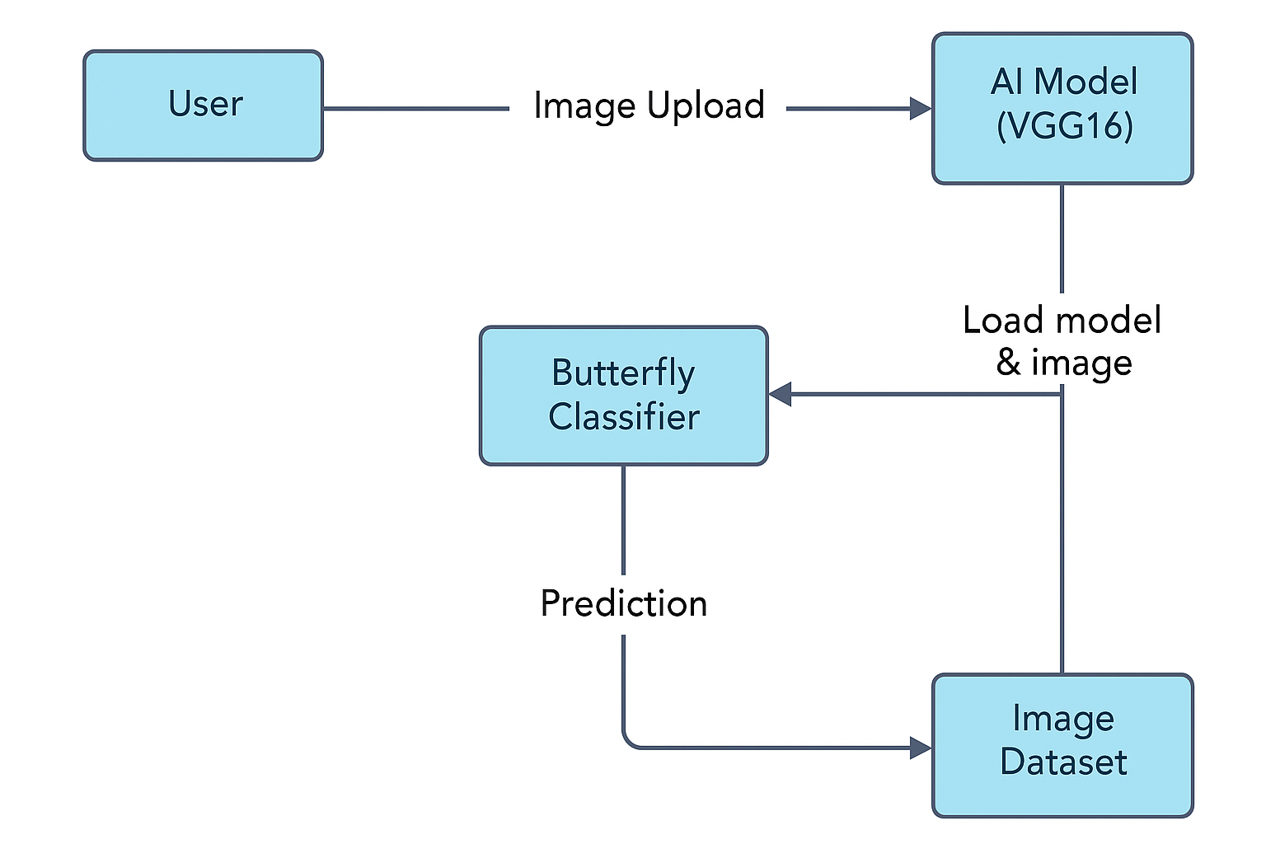

## 📊 Level 1 DFD

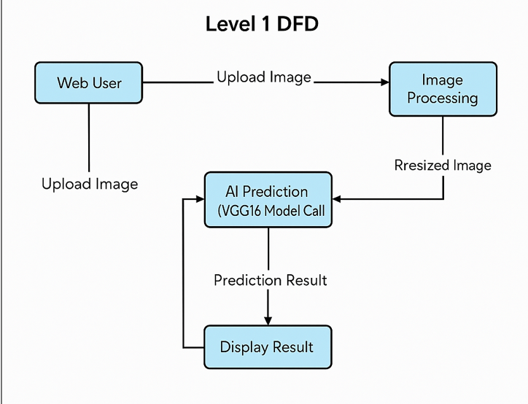  
Process Breakdown:  
1. User Interaction: Image upload via web interface.  
2. Image Processing: Resize and normalize image.  
3. Prediction: Image passed to model and prediction made.  
4. Result Display: Prediction shown on the dashboard.

# 🧾 User Stories

|  |  |  |  |  |  |
| --- | --- | --- | --- | --- | --- |
| User Type | Functional Requirement (Epic) | User Story Number | User Story / Task | Acceptance Criteria | Priority / Release |
| Web User (Citizen / Student) | Upload & Classify Butterfly Image | USN-1 | As a user, I can upload an image to identify butterfly species. | I can upload an image and see the predicted butterfly species. | High / Sprint-1 |
|  |  | USN-2 | As a user, I can view the prediction result clearly on the dashboard. | The name of the butterfly is shown along with the uploaded image. | High / Sprint-1 |
|  | Register/Login (Optional) | USN-3 | As a user, I can login using email or social login to track history. | I can login and view my past predictions. | Medium / Sprint-2 |
| Admin | Manage Dataset | USN-4 | As an admin, I can update the image dataset if new species are added. | Dataset is maintained and new classes are reflected in predictions. | High / Sprint-2 |
| Admin | Monitor Predictions | USN-5 | As an admin, I can view logs of user predictions for analytics and improvement. | Admin dashboard shows usage logs and stats. | Medium / Sprint-3 |
| Researcher | Track Species Data | USN-6 | As a researcher, I can use predictions to analyze habitat or species frequency. | Export option for prediction logs with timestamps. | Low / Sprint-3 |